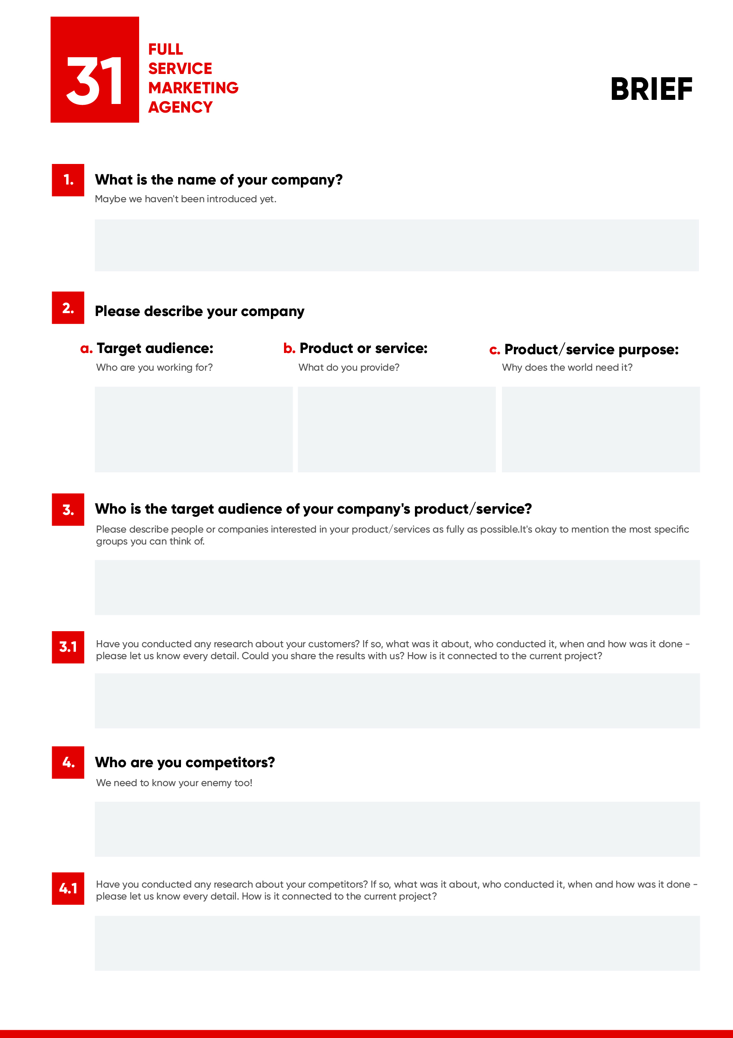

Type your answer here…

Type your answer here…

Type your answer here…

Type your answer here…

Type your answer here…

Type your answer here…

Type your answer here…

Type your answer here…

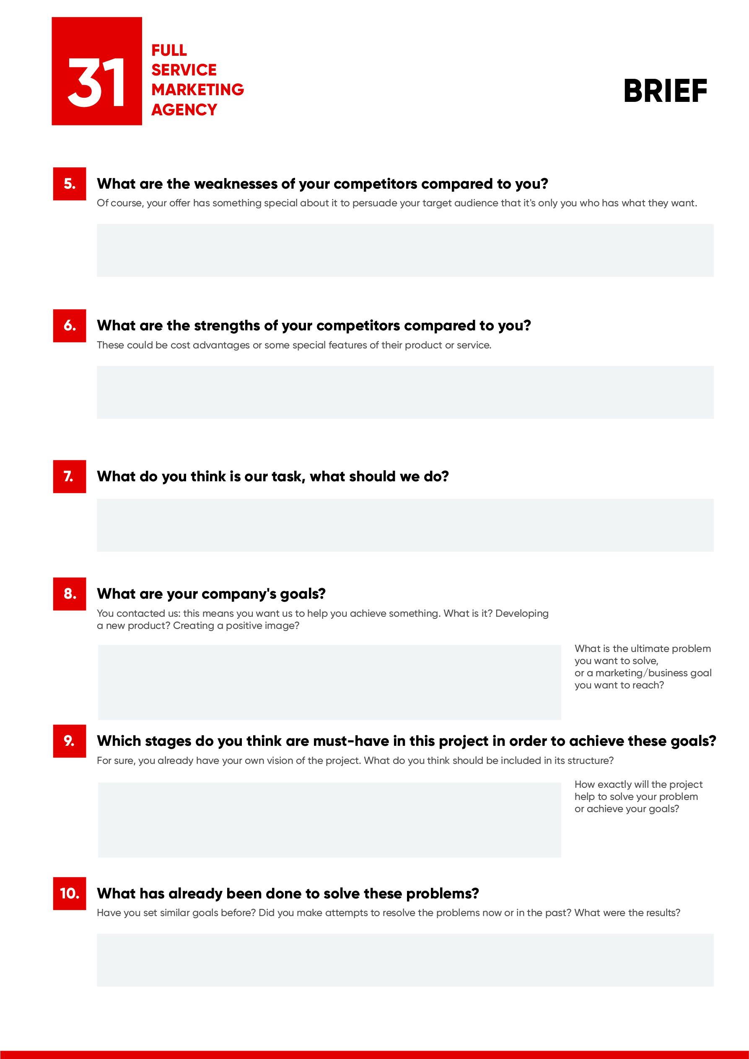

Type your answer here…

Type your answer here…

Type your answer here…

Type your answer here…

Type your answer here…

Type your answer here…

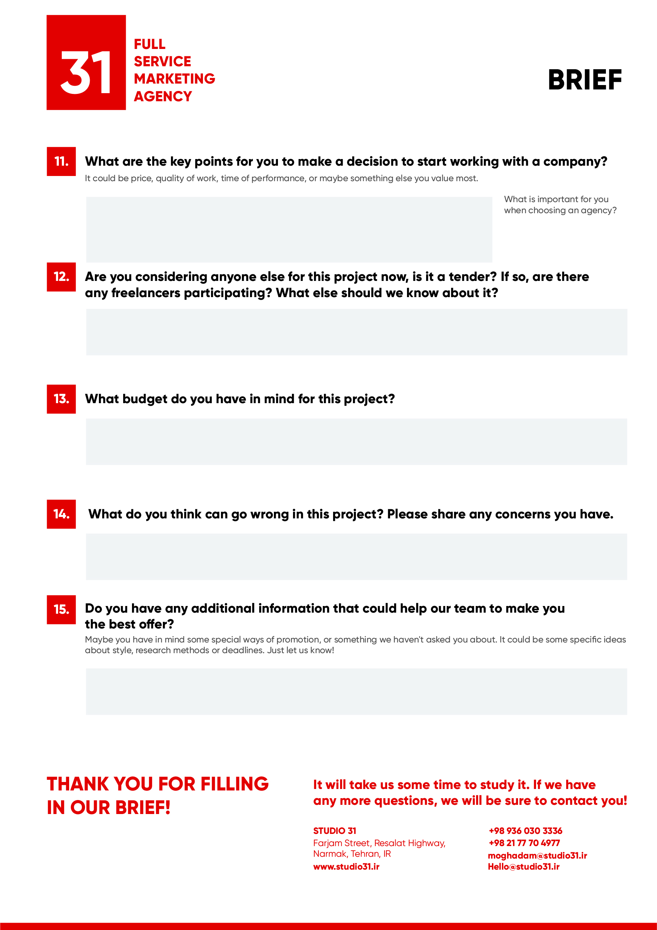

Type your answer here…

Type your answer here…

Type your answer here…

Type your answer here…

Type your answer here…